Ecosystem ecology

Lab 10: Ecosystem metabolism

- Ecosystem metabolism and services

A.G. Tansley (1935) published the term ecosystem roughly 20 years after Clements described the superorganism concept. He wrote: “But the more fundamental conception is, as it seems to me, the whole system (in the sense of physics), including not only the organism-complex, but also the whole complex of physical factors forming what we call the environment of the biome – the habitat factors in the widest sense. Though the organisms may claim our primary interest, when we are trying to think fundamentally we cannot separate them from their special environment, with which they form one physical system…These ecosystems, as we may call them, are of the most various kinds and sizes. They form one category of the multitudinous physical systems of the universe, which range from the universe as a whole down to the atom” (Tansley 1935).

Nearly every aquatic ecosystem in Florida is undergoing change. Sometimes these changes are natural or imperceptible. Other times, and more often, these aquatic systems are adjusting to channeling by canals, floods, droughts, changes in salinity, or changes in nutrient loads imposed in years past by human activity. Understanding the current status and tendencies of these systems and what changes may be anticipated in the future is integral to protection, management, and restoration decisions of these waterways. Research on this topic and management decisions often have long-reaching effects on the human population as many of these bodies of water provide invaluable ecosystem goods and services. Ecosystem goods (such as food) and services (such as waste assimilation) represent the benefits human populations derive, directly or indirectly, from ecosystem functions (Costanza et al. 1997). Some examples of ecosystem services are: erosion control, waste treatment, water regulation and supply, food production, nutrient cycling, climate regulation, and hurricane surge protection.

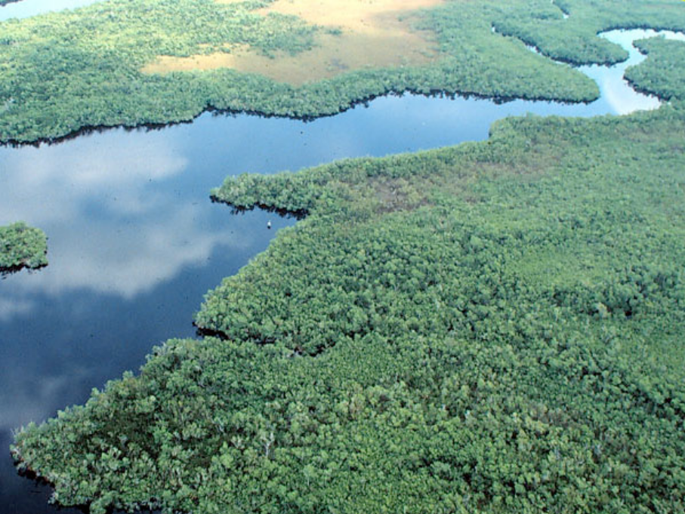

Figure 1: Example ecosystem, the Florida Everglades

Tansley’s definition stressed the conceptual unification of organisms (biotic components) and contextual physical factors (abiotic components) into a single system. Thus, we define an ecosystem as the biotic components of a given habitat (i.e., the communities) and the abiotic environment of that habitat. Ecosystem-level approaches in ecology emphasize the interaction between biotic and abiotic elements. Frequently ecosystem scientists study exchanges between ecosystem components. Such exchanges produce emergent functional properties of the ecosystem itself. Examples of ecosystem emergent properties are energy flow and nutrient cycling.

Energy flow is a fundamental property of ecosystems that links organisms to their environment.
Photosynthetic autotrophs capture energy from their environment (i.e., sunlight) to create organic molecules from inorganic carbon, water, and nutrients. Energy stored in photosynthate moves up a food chain or across a food web when heterotrophic organisms consume autotrophs or other heterotrophs. Energy transfer during these consumption events is not perfectly efficient. The second law of thermodynamics states that although an energy transformation or transfer does not change the total amount of energy within a closed system (e.g., the universe), the amount of energy available to do work after the transfer is always less than the original amount of energy (Purves et al. 1998). That is, trophic efficiency at any level in a food web is always less than 100%. Only 10 – 20% of the energy at one trophic level in a food web is actually transferred to the next trophic level.

- Ecosystem metabolism is not limitless

Autotrophs (i.e., primary producers) introduce the majority of all energy input to the ecosystem food web. There are some important exceptions, though. Some ecosystems receive energy as organic matter that flows in from outside the system. A lake fed by rivers is an example of such an ecosystem that receives allochthonous energy inputs in addition to the autochthonous energy captured within the system by suspended phytoplankton and wetland plants in the lake’s shallows fringe. Since energy flow in ecosystems strongly depends on primary production, we can investigate the factors that control primary production rates and, thereby, ecosystem metabolism. Both the biotic and abiotic components of an ecosystem control its metabolism.

Biotic controls include genetic limits to organismal growth rates or competition among organisms in ecosystems. Abiotic ecosystem components that regulate whole-system metabolism are also termed forcing functions. Examples of forcing functions are light and nutrient availability.

- Control of light on system metabolism

Since the biochemical entry point for energy flow through food webs (i.e., photosynthesis) depends on sunlight, the control of light on primary productivity in an ecosystem is obvious. In terrestrial ecosystems, light availability is influenced by shading, which drives competition among plant species. While shading is also a factor in aquatic ecosystems, the main control on light availability across water depths is light attenuation. As water depth increases, available light declines exponentially from the amount available at the water surface. Clear water has a low attenuation coefficient, meaning that light penetrates to relatively greater depths. Turbid or colored water bodies tend to have higher attenuation coefficients.

- Control of nutrients on system metabolism

The availability of inorganic nutrients also frequently controls ecosystem-level primary productivity. The German chemist Justus von Liebig (1803 – 1873) investigated the mineral nutrition of plants in agricultural systems. During his studies he realized that crop yield could be increased by fertilizer additions only if the soil present contained all the other necessary nutrients (Liebig 1840). Since then, his ideas have been generalized into Liebig’s Law of the Minimum, which states that the elemental nutrient least available in a system relative to its requirement by primary producers is the limiting nutrient. Carbon (C), nitrogen (N), and phosphorous (P) are known as macronutrients since primary producers require relatively large amounts of these elements to grow. For example, inorganic N is required for plants to synthesize amino acids and proteins while inorganic P is essential for synthesis of nitrogenous bases, adenosine triphosphate (ATP) and related compounds, and nucleic acids. C, N, and P often limit ecosystem metabolism by limiting primary productivity.

The Everglades ecosystem is oligotrophic (i.e., nutrient poor) and P limited. Recent evidence of historical P limitation in the Everglades comes from the effects of P fertilizer applied to sugar cane fields north of the Everglades. Fertilizers arrive as P-enriched runoff to marsh plant communities in the Everglades where, as a result, cattail (Typha domingensis Pers.) expands out-competes for space with oligotrophic-adapted sawgrass (Cladium jamaicense Crantz) (Doren et al. 1997, King et al. 2004). To investigate the interactions in aquatic habitats similar to those in the Everglades, we will work in ponds on campus.

The ratios of C, N, and P that primary producers require vary among species. For unicellular algae such as phytoplankton and the algae in periphyton, this ratio is very close to 106:16:1 on a molar basis. The 106:16:1 ratio is known as the Redfield ratio, named after the late Harvard physiologist Alfred C. Redfield (1890-1983). Using this ratio along with data on nutrient availability, we can determine which nutrient is limiting for primary production in any environment. For example, if we know that N and P availabilities in a habitat are 6000 and 300 mg/m³, respectively, then we can divide each value by its corresponding Redfield ratio number (e.g., 6000/16 = 375 for N and 300/1 = 300 for P). The result is that the lowest value is produced for P, which is then the limiting nutrient for primary production in our example. While ecologists and physiologists have typically considered the Redfield ratio to be an optimal ratio for primary production, recent research has shown that the Redfield ratio is actually an average that is subject to change depending on future levels of nutrient availability and competition in the environment (Klausmeier et al. 2004).

- Measuring ecosystem metabolism

Ecosystem ecologists measure whole-system metabolism in a manner similar to the way an organismal biologist measures the metabolic rate of a single organism. Since oxygen and carbon dioxide can be stoichiometrically related to photosynthesis (i.e., autotrophic processes) and respiration (i.e., heterotrophic processes), following their transfer is a way to measure ecosystem metabolism. Consider oxygen flux in an ecosystem. If there is a net gain of oxygen in a system over time, then photosynthesis has exceeded respiration, meaning that the system is autotrophic. A net loss of oxygen over time indicates that ecosystem respiration exceeds photosynthesis, meaning that the system is heterotrophic. By definition, all terrestrial systems are heterotrophic at night since no sunlight is available for photosynthesis. If over an entire 24 hour period a system fixes more carbon than is consumed, the system is autotrophic because photosynthetic carbon gains exceed respiratory carbon losses.

To experimentally examine system metabolism, ecologists use enclosures to measure ecosystem respiration (R) as oxygen change in the absence of light (e.g., in a dark enclosure during the day or a clear enclosure at night) and net primary production (NPP) during the day in a clear enclosure. Both photosynthesis and respiration occur during the day in a clear enclosure where oxygen is produced by photosynthesis and simultaneously consumed by respiration (NPP). If respiration in the absence of light is assumed to be equal to respiration in the clear enclosure, then gross primary production (GPP) can be calculated as oxygen change in a clear chamber plus oxygen change in a dark chamber (NPP = GPP + R).
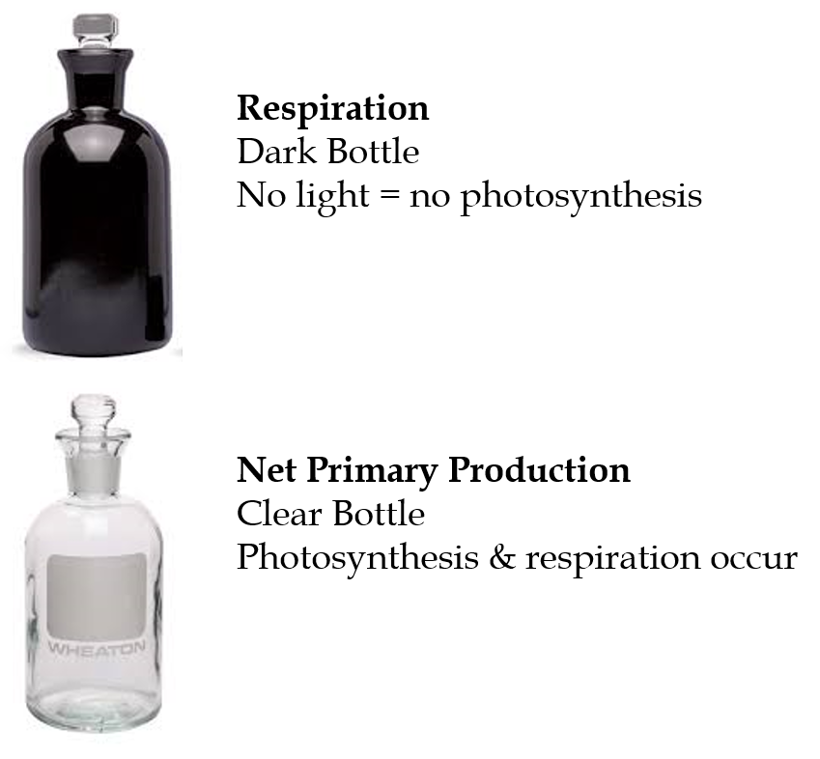

In today’s lab, you will be using this technique to look at ecosystem metabolism in Library Pond. Your ecosystem enclosures will be clear and black bottles that we will fill, seal, and incubate for a set period of time. This is known as a light-dark bottle experiment. NPP and R are simply:
NPP = [O₂ light]_{final} - [O₂ light]_{initial}
R = [O₂ dark]_{finall} - [O₂ dark]_{initial}
NPP = GPP + R
Note that, unless something is very wrong, the final oxygen concentration in your light bottles should be greater than the initial concentration while the final oxygen concentration in your dark bottles should be less than the initial. There are few methods commonly used to measure oxygen concentration. The two most frequently used are the Winkler Titration method and oxygen electrode/meters. The Winkler titration uses chemical reactions to fix all free oxygen in a sample, meaning that your sample must be sacrificed but also meaning that you get an exact and real oxygen concentration. Oxygen meters use a gold-tipped electrode to electrically estimate oxygen concentration based on the rate of oxygen diffusion across a permeable membrane that is fit over the electrode. Meters must thus be calibrated to known oxygen concentrations, and the most reliable calibration method for a meter is the Winkler titration. For ease and simplicity, you will be using oxygen meters in lab today.
You will be using this light-dark bottle experiment to partition NPP, GPP, and R for two communities of primary producers: phytoplankton and periphyton (or plant), from 3 ponds. To do this, each group will have a treatment of just water (with phytoplankton) and a treatment of water + periphyton (or plant). It is important to consider the components of the Pond ecosystem that you are NOT including in these light-dark bottle measurements when you analyze your results. Take notes on differences between sites.
Purpose:

- Compare ecosystem metabolism between two communities of primary producers: phytoplankton and periphyton/plant (whichever is available).
- To compare ecosystem metabolism among ponds.

Before going outside
- Split evenly into 4 groups
- Generate hypotheses
- Prepare data sheet

Group # | Autotrophs | Bottle Type | Time | Temperature (°C) | Initial O₂ | Final O₂ | O₂ change
(1-4) | (Phytoplankton or Plant/periphyton) | (Light or dark)

Once outside:
- Fill your bottles (12 total: 6 dark, 6 light) with water from the pond
  - Make sure there is no space for air between the glass caps and water!
- Periphyton/plant treatment: in half of your bottles (3 light and 3 dark) place a small (~1 cm) piece of periphyton or plant inside your bottle
- Phytoplankton treatment: don’t add anything - the phytoplankton are already there!
- Take initial measurements of O₂ and temperature using your O₂ probes (Don’t forget to record the time!).
- Place the bottles in the sun and leave for 10 minutes..
- Gently remove the glass caps taking care to not create bubbles.
- Insert the O₂ probe and take final measurements of O₂. (mg/l)

Field Instructions:

Take notes on the following questions as possible discussion points in your lab report.

1) Geologic/Pond substrate structure (is the pond shallow/deep? Large/small? Is the bottom limestone/soil/periphyton/floc? )
2) Plant structure inside and surrounding the pond (mostly submerged, emergent, or facultative wetland plants? Periphyton? Algae?)
3) Organisms present (larval/flying insects? Small/large fish? Birds? Turtles? Mammals?)
4) Are there any obvious allochthonous/autochthonous inputs?
5) Are there any obvious signs of pollutants or nutrient inputs?

Literature Cited
Costanza, Robert, et al. "The value of the world's ecosystem services and natural capital." nature 387.6630 (1997): 253-260.

Doren, R. F., T. V. Armentano, L. D. Whiteaker, and R. D. Jones. 1997. Marsh vegetation patterns and soil phosphorous gradients in the Everglades ecosystem. Aquatic Botany 56:145-163.

King, R. S., C. J. Richardson, D. L. Urban, and E. A. Romanowicz. 2004. Spatial dependency of vegetation-environment linkages in an anthropogenically influenced wetland ecosystem. Ecosystems 7:75-97.

Klausmeier, C. A., E. Litchman, T. Daufresne, and S. A. Levin. 2004. Optimal nitrogen-tophosphorous stoichiometry of phytoplankton. Nature 429:171-174.

Liebig, J. v. 1840. Die Organische Chemie in ihre Anwendung auf Agricultur und Physiologie. Braunschweig.

Purves, W. K., G. H. Orians, H. C. Heller, D. Sadava. 1998. Life: The science of biology. 5th Edition. Sinauer Associates, Inc., Sunderland, MA.

Tansley, A. G. 1935. The use and abuse of vegetational terms and concepts. Ecology 16:284- 307.

Further Reading

Lin, H. J., J. J. Hung, K. T. Shao, F. Kuo. 2001. Trophic functioning and nutrient flux in a highly productive tropical lagoon. Oecologia 129(3):395-406.

Masini, R. J., P. K. Anderson, A. J. McComb. 2001. A Halodule-dominated community in a subtropical embayment: Physical environment, productivity, biomass, and impact of dugong grazing. Aquatic Botany 71(3):179-197.

McCormick, P. V., J. A. Laing. 2003. Effects of increased phosphorous loading on dissolved oxygen in a subtropical wetland, the Florida Everglades. Wetlands Ecology and Management 11(3):199-215.

Viaroli, P., and R. R. Christian. 2004. Description of trophic status, hyperautotrophy and dystrophy of a coastal lagoon through a potential oxygen production and consumption index – TOSI: Trophic Oxygen Status Index. Ecological Indicators 3(4):237-250.

