Ecological Sampling Techniques

This worksheet is designed to help you to:
- Understand basic field sampling techniques.
- Present collected data in a manner suitable for analysis.
- Analyze and interpret field-collected data.

Answer/address all of the following questions using complete sentences. When conducting statistical analyses or creating figures, remember to refer to the Ecological Statistics PowerPoint available on the Ecology Lab webpage for details. You are expected to follow all figure-making details from that PowerPoint. You are using the class data, not group data. Total = 65 pts

1. State in your own words why it is necessary to conduct random sampling within a habitat. (2 pts)

2. Explain the difference between accuracy and precision. Which would you prefer to have in your sampling? Why? (4 pts)

3. (a) Present a table summarizing the mean and standard deviation of each species density (number of individuals per m²) estimated from the quadrat sampling. Include an appropriate and specific title for your table. Do not include raw data. (5 pts)

(b) Produce a bar graph showing the mean density of each species from the quadrat sampling. Include error bars and remember to label and title your graph (4 pts).

(c) Using the mean densities that you calculated from the quadrat sampling data, what do you estimate the total population size of each species to be for the entire study area? (2 pts)

4. Perform an appropriate statistical test to determine if there is a significant difference in abundance among the FOUR species calculated from the quadrat sampling.

(a) State the statistical Ho and Ha. (2 pts)

(b) Present the statistical output and highlight the appropriate P-value. Hint: Use an ANOVA on the raw sampling data. (5 pts)

(c) Evaluate your P-value. Do you reject or fail to reject your null hypothesis and why? (2 pts)

(d) Write out your conclusion. (1 pt)

5. (a) Present a table summarizing the mean and standard deviation of each species density (number of individuals per m²) estimated from the transect sampling. Include an appropriate and specific title for your table. Do not include raw data. (5 pts)

(b) Produce a bar graph showing the mean density of each species from the transect sampling. Include error bars and remember to label and title your graph (4 pts).

(c) Using the mean densities that you calculated from the transect sampling data, what do you estimate the total population size of each species to be for the entire study area? (2 pts)

6. Perform an appropriate statistical test to determine if there is a significant difference in abundance among the FOUR species calculated from the transect sampling.

(a) State the statistical Ho and Ha. (2 pts)

(b) Present the statistical output and highlight the appropriate P-value. Hint: Use an ANOVA on the raw sampling data. (5 pts)

(c) Evaluate your P-value. Do you reject or fail to reject your null hypothesis and why? (2 pts)

(d) Write out your conclusion. (1 pt)

7. Use the quadrat sampling data to examine species distributions (random, uniform, or clumped).

- For Species C, create a histogram. Your x-axis will be number of individuals in a quadrat and your y-axis will be the proportion of quadrats that have that number of individuals. Do not forget to title and label your graphs. Hint: Follow the directions in the Ecological Statistics PowerPoint. (4 pts)

The following data table and histogram are an example. Do not submit this example graph. You must create your own.

Number of Individuals | Number of Quadrats | Proportion of Quadrats
0 | 1 | 1/10 = 0.1
1 | 2 | 2/10 = 0.2
2 | 4 | 4/10 = 0.4
3 | 2 | 2/10 = 0.2
4 | 1 | 1/10 = 0.1

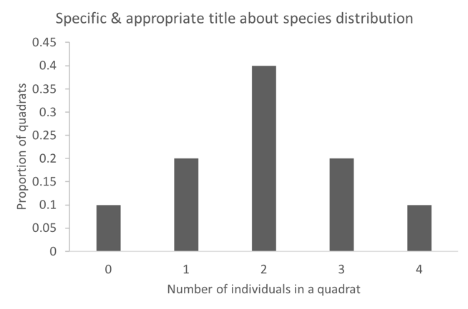

- What type of species distribution is Species C exhibiting? Discuss one ecological factor that may explain the type of species distribution that you observed. (3 pts)
8. Given the true size of each species population (A = 5, B = 25, C = 35, D = 20), present your conclusion and discuss the findings of your analysis.

(a) Create a table that shows the true population sizes (see above in Question 8) and the estimated population sizes that you obtained from transect and quadrat sampling. Which sampling technique obtained results that were more accurate (closer to the true population sizes)? (4 pts)

(b) What are some potential sources of bias in your experiment? How would you increase the accuracy and precision of your sampling methods if you were going to do this experiment again? (2 pts)

(c) What did the data analysis teach you about the application of different sampling methods? (2 pts)

(d) How do you think this class exercise is similar to and different from professional biologists sampling real plants and animals? (2 pts)

